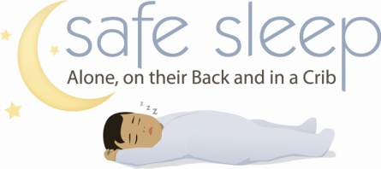
Safe Sleep for Babies Caregiver Survey
Pretest
- What are the ABCs of safe sleep?

- How will you lay your baby down to sleep?
□ On the back n □ On the tummy n □ On the side n □ Not sure

- Where will your baby sleep at home?
□ In a bassinet next to my bed n □ In a crib in the baby’s room □ Don’t know/not sure
□ In a portable crib next to my bed n □ In a big bed □ Other (specify) _____________
□ In a crib in my room n □ In my bed

- Please check the items that are already in your baby’s sleeping area at home, or that you plan to get for your baby’s sleeping area.
□ Firm Mattress n □ Blanket n □ Pillow □ Sleep Positioner
□ Fitted Sheet n □ Bumper Pad n □ Stuffed Toy □ Other_____________

- Will you talk about Safe Sleep with others who may put your child down to sleep? □ Yes □ No

Date: __________________
Visit kidsks.org for more safe sleep information.

Safe Sleep for Babies Caregiver Survey
Posttest
- What are the ABCs of safe sleep?

- How will you lay your baby down to sleep?
□ On the back n □ On the tummy n □ On the side n □ Not sure

- Where will your baby sleep at home?
□ In a bassinet next to my bed n □ In a crib in the baby’s room □ Don’t know/not sure
□ In a portable crib next to my bed n □ In a big bed □ Other (specify) _____________
□ In a crib in my room n □ In my bed

- Please check the items that are already in your baby’s sleeping area at home, or that you plan to get for your baby’s sleeping area.
□ Firm Mattress n □ Blanket n □ Pillow □ Sleep Positioner
□ Fitted Sheet n □ Bumper Pad n □ Stuffed Toy □ Other_____________

- Will you talk about Safe Sleep with others who may put your child down to sleep? □ Yes □ No

Date: __________________
Visit kidsks.org for more safe sleep information.

